

GITAM Bengaluru Campus, NH 207, Nagadenahalli Doddaballapura

Taluk, Bengaluru Rural District-561203

“**Automatic Door Bell Ringer**”

**Atigadda Madhankumar Chetty**

**2024099528**

**MTech in VLSI Design**

**Technical Seminar**

**GITAM University, Bangalore**

Table of Contents

1.Introduction : 5

2.Apparatus Required : 5

3.Working Principle: 5

5.State-of-the-Art 6

2000 - 2010 9

2011 - 2020 9

2021 - 2025 10

5.My Requirement : 11

6.Circuit Implementation Details: 12

7.Testing & Results: 13

8.Cost Analysis: 15

9.Challeges Faced : 15

10.Applications: 16

11.Limitations: 16

12.Conclusion: 17

13.References: 17

# Table Of Figures

Figure 1:Automatic Door Bell Ringer Schematic 12

Figure 2:Output When Buzzer is On 14

Figure 3:Output when Buzzer is OFF 14

# List of Tables

Table 1:State-of-the-Art: Automatic Door Bell Ringer 9

# 1.Introduction :

The **Automatic Door Bell Ringer** is an innovative system designed to enhance convenience and accessibility by automating the process of ringing a doorbell. Unlike traditional doorbells that require manual operation, this system detects the presence of a visitor and activates the bell automatically. It is particularly useful in homes, offices, hospitals, and public buildings, ensuring a touch-free and efficient way to alert occupants of an arrival.

By utilizing motion sensors or infrared technology, the Automatic Door Bell Ringer eliminates the need for physical contact, making it a hygienic and user-friendly solution. This system not only improves security by detecting movement near the entrance but also provides ease of access for individuals with mobility challenges. With its simple yet effective functionality, the Automatic Door Bell Ringer is a step toward modernizing everyday interactions at doorways.

# 2.Apparatus Required :

1. **555 Timer IC (U1)** – LM555CM
2. **Resistors**
3. R1: 3.7kΩ
4. R2: 100kΩ
5. R3: 10kΩ
6. R4: 10kΩ
7. **Capacitors**
8. C1: 470µF
9. C2: 0.01µF
10. **Photo Diode (LED)** – Light sensor for detection
11. **Photo Transistor** – Acts as a switch when light falls on it
12. **Transistor (Q1)** – BC547BP (NPN transistor)
13. **Buzzer (LS1)** – 200Hz sound output
14. **Oscilloscope (XSC1)** – For signal observation

# 3.Working Principle:

**Working Principle of Automatic Door Bell Ringer**

The **Automatic Door Bell Ringer** operates based on an infrared (IR) sensor system, a 555 timer IC, and a buzzer to detect motion and generate an alert sound. The system is designed to detect the presence of a visitor and automatically activate the doorbell without requiring manual operation.

**Step-by-Step Working:**

1. **Detection of Motion:**
   * The circuit includes a **photo diode and photo transistor** that act as an infrared sensor pair.
   * When an object (such as a person) interrupts the IR beam, the **photo transistor** changes its conductivity.
2. **Triggering the 555 Timer IC:**
   * The change in the sensor's output triggers the **NPN transistor (BC547BP)**, which acts as a switch.
   * This, in turn, activates the **555 Timer IC (LM555CM)** configured in monostable mode.
   * The 555 timer generates a pulse signal for a specific duration.
3. **Activating the Buzzer:**
   * The output of the 555 timer is connected to a **buzzer (200Hz)**.
   * When triggered, the buzzer produces an audible sound, indicating the presence of a visitor.
4. **Resetting the System:**
   * After the set time determined by the **resistors (R1, R2, R3, R4) and capacitors (C1, C2)**, the timer resets itself.
   * The system returns to its standby state, ready to detect the next visitor.

**Key Features:**

* **Touchless Operation:** Ensures hygiene and ease of use.
* **Automatic Activation:** Rings the bell only when a person is detected.
* **Energy Efficient:** Consumes power only when triggered.
* **Simple & Cost-Effective Design:** Uses basic electronic components for implementation.

This working principle makes the **Automatic Door Bell Ringer** highly suitable for homes, offices, and commercial buildings, enhancing both security and convenience.

# State-of-the-Art

|  |  |  |  |  |  |
| --- | --- | --- | --- | --- | --- |
| Time Period | Category | Product Name | Manufacturer | Cost (₹) | Features, Advantages & Disadvantages |
| 2000 - 2010 | Low-Cost | DingDong Basic Doorbell | DingDong Electronics | ₹500 - ₹1000 | Wired operation, simple push-button mechanism. Advantages: Affordable, easy to install, reliable. Disadvantages: No automation, requires manual operation. |
| 2000 - 2010 | Medium-Cost | RF-Based Wireless Doorbell | Panasonic | ₹1500 - ₹2500 | RF signal-based transmission, up to 50m range. Advantages: Wireless, battery-powered, easy to install. Disadvantages: Limited range, interference issues. |
| 2000 - 2010 | High-Cost | Smart Sensor Doorbell | Honeywell | ₹4000 - ₹6000 | Motion detection, adjustable volume levels. Advantages: Motion-activated, customizable chimes. Disadvantages: No internet connectivity, limited range. |
| 2011 - 2020 | Low-Cost | PIR Motion Sensor Doorbell | Generic Brand | ₹1000 - ₹2000 | Infrared motion detection, battery-powered. Advantages: Energy-efficient, compact design. Disadvantages: False triggers, limited sensing distance. |
| 2011 - 2020 | Medium-Cost | Wi-Fi Enabled Smart Doorbell | Ring | ₹8000 - ₹12000 | Two-way audio, video recording, app control. Advantages: Remote access, smartphone notifications. Disadvantages: Requires Wi-Fi, high power consumption. |
| 2011 - 2020 | High-Cost | Google Nest Hello | Google | ₹15,000 - ₹20,000 | AI face recognition, cloud storage, night vision. Advantages: High security, smart home integration. Disadvantages: Expensive, requires subscription for full features. |
| 2021 - 2025 | Low-Cost | AI-Powered PIR Doorbell | Xiaomi | ₹2000 - ₹4000 | PIR sensor, AI-based motion detection. Advantages: Affordable, energy-efficient. Disadvantages: Limited cloud storage. |
| 2021 - 2025 | Medium-Cost | IoT-Enabled Smart Doorbell | Wyze | ₹7000 - ₹12000 | Wi-Fi connectivity, two-way audio, AI detection. Advantages: Smart assistant integration, mobile alerts. Disadvantages: Requires strong internet connection. |
| 2021 - 2025 | High-Cost | Edge AI-Based Doorbell | Arlo | ₹20,000 - ₹30,000 | Local AI processing, enhanced security. Advantages: Faster response, no cloud dependency. Disadvantages: High initial cost. |

**Table 1:State-of-the-Art: Automatic Door Bell Ringer**

## 2000 - 2010

1. **Low-Cost Product**: DingDong Basic Doorbell (2003)
   * **Manufacturer**: DingDong Electronics
   * **Cost**: ₹500 - ₹1000
   * **Features**: Wired operation, simple push-button mechanism.
   * **Advantages**: Affordable, easy to install, reliable.
   * **Disadvantages**: No automation, requires manual operation.
2. **Medium-Cost Product**: RF-Based Wireless Doorbell (2007)
   * **Manufacturer**: Panasonic
   * **Cost**: ₹1500 - ₹2500
   * **Features**: RF signal-based transmission, up to 50m range.
   * **Advantages**: Wireless, battery-powered, easy to install.
   * **Disadvantages**: Limited range, interference issues.
3. **High-Cost Product**: Smart Sensor Doorbell (2010)
   * **Manufacturer**: Honeywell
   * **Cost**: ₹4000 - ₹6000
   * **Features**: Motion detection, adjustable volume levels.
   * **Advantages**: Motion-activated, customizable chimes.
   * **Disadvantages**: No internet connectivity, limited range.

## 2011 - 2020

1. **Low-Cost Product**: PIR Motion Sensor Doorbell (2013)
   * **Manufacturer**: Generic Brand
   * **Cost**: ₹1000 - ₹2000
   * **Features**: Infrared motion detection, battery-powered.
   * **Advantages**: Energy-efficient, compact design.
   * **Disadvantages**: False triggers, limited sensing distance.
2. **Medium-Cost Product**: Wi-Fi Enabled Smart Doorbell (2017)
   * **Manufacturer**: Ring
   * **Cost**: ₹8000 - ₹12000
   * **Features**: Two-way audio, video recording, app control.
   * **Advantages**: Remote access, smartphone notifications.
   * **Disadvantages**: Requires Wi-Fi, high power consumption.
3. **High-Cost Product**: Google Nest Hello (2019)
   * **Manufacturer**: Google
   * **Cost**: ₹15,000 - ₹20,000
   * **Features**: AI face recognition, cloud storage, night vision.
   * **Advantages**: High security, smart home integration.
   * **Disadvantages**: Expensive, requires subscription for full features.

## 2021 - 2025

1. **Low-Cost Product**: AI-Powered PIR Doorbell (2022)
   * **Manufacturer**: Xiaomi
   * **Cost**: ₹2000 - ₹4000
   * **Features**: PIR sensor, AI-based motion detection.
   * **Advantages**: Affordable, energy-efficient.
   * **Disadvantages**: Limited cloud storage.
2. **Medium-Cost Product**: IoT-Enabled Smart Doorbell (2023)
   * **Manufacturer**: Wyze
   * **Cost**: ₹7000 - ₹12000
   * **Features**: Wi-Fi connectivity, two-way audio, AI detection.
   * **Advantages**: Smart assistant integration, mobile alerts.
   * **Disadvantages**: Requires strong internet connection.
3. **High-Cost Product**: Edge AI-Based Doorbell (2024)
   * **Manufacturer**: Arlo
   * **Cost**: ₹20,000 - ₹30,000
   * **Features**: Local AI processing, enhanced security.
   * **Advantages**: Faster response, no cloud dependency.
   * **Disadvantages**: High initial cost.

# 5.My Requirement :

I am preparing an **Automatic Door Bell Ringer**—a circuit-based system that detects when someone approaches a door and automatically triggers a doorbell sound. This system is designed to operate without any manual intervention, ensuring a hygienic and user-friendly experience.

**Key Features**

* **Automatic Motion Detection:**  
  The system uses an infrared (IR) sensor pair (photo diode and photo transistor) to detect motion or presence near the door.
* **Touch-Free Operation:**  
  Eliminates the need for physical contact by automatically activating the doorbell upon detecting an approaching person.
* **Integrated Timer Circuit:**  
  A 555 Timer IC is used in a monostable configuration to control the duration of the doorbell ring, ensuring the signal is generated for a set period.
* **Signal Amplification:**  
  An NPN transistor (such as the BC547BP) amplifies the sensor’s signal, ensuring reliable activation of the timer circuit.
* **Audible Alert:**  
  A 200Hz buzzer serves as the doorbell, producing an audible sound when the circuit is triggered.
* **Energy Efficiency:**  
  The circuit is designed to operate only when a presence is detected, conserving power during idle times.
* **Simple and Cost-Effective Design:**  
  Utilizes common electronic components and can be easily assembled on a breadboard or PCB, making it accessible for both beginners and experienced hobbyists.

# 6. Circuit Implementation Details:

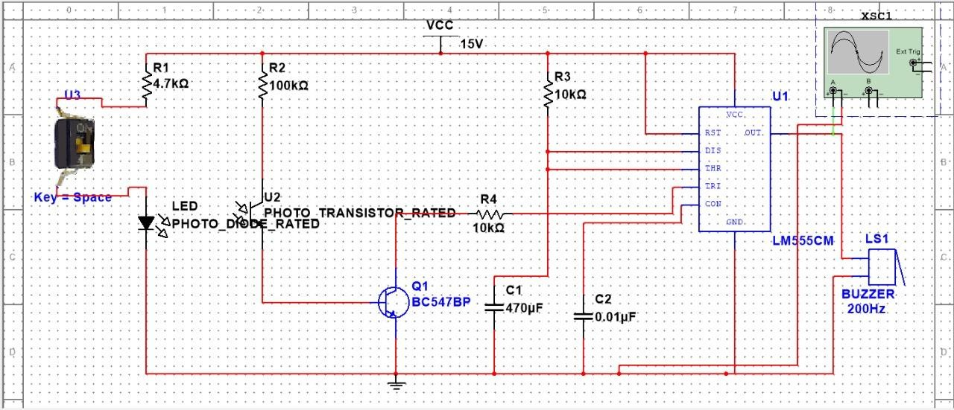

**Figure 1:Automatic Door Bell Ringer Schematic**

This circuit is an **Automatic Door Bell Ringer** that operates using an **infrared (IR) sensor** and a **555 Timer IC** to generate a buzzer sound when a person is detected near a door.

**Circuit Components and Working:**

1. **Infrared (IR) Sensor Pair (U3 - IR LED & U2 - Phototransistor)**
   * The **IR LED** continuously emits infrared light.
   * The **Phototransistor (U2)** receives this IR light under normal conditions.
   * When an object (such as a person) interrupts the IR beam, the phototransistor stops conducting.
2. **Transistor Amplification (Q1 - BC547BP)**
   * The change in the phototransistor’s state is amplified by **Q1 (NPN transistor BC547BP)**.
   * This amplified signal is used to trigger the **555 Timer IC**.
3. **555 Timer IC (U1 - LM555CM)**
   * The **555 Timer** is configured in **monostable mode**.
   * When triggered by the IR sensor, it generates a timed pulse.
   * The pulse duration is determined by **resistor R3 (10kΩ) and capacitors C1 (470µF) & C2 (0.01µF)**.
4. **Buzzer (LS1 - 200Hz Sound Output)**
   * The output pulse from the **555 Timer** activates the **buzzer (LS1)**.
   * The buzzer generates an audible sound (200Hz frequency) as an alert.
5. **Oscilloscope (XSC1 - Signal Monitoring)**
   * Used for signal analysis and debugging.
   * Displays waveform of the 555 Timer output.

**Operation Summary:**

1. The IR LED emits infrared light towards the phototransistor.
2. When a person obstructs the IR beam, the phototransistor stops conducting.
3. The transistor (BC547BP) amplifies this signal and sends it to the 555 Timer.
4. The 555 Timer generates a timed pulse that turns on the buzzer.
5. The buzzer sounds for a fixed duration, alerting the presence of a visitor

# 7.Testing & Results:

**Testing Procedure:**

* **Step 1:** Connect the circuit components as per the schematic diagram.
* **Step 2:** Power the circuit with a **15V DC supply**.
* **Step 3:** Check the IR sensor operation:
  + If the path is clear, the **phototransistor should be conducting** (no buzzer sound).
  + If an object obstructs the IR beam, the **phototransistor should stop conducting**, triggering the next stage.
* **Step 4:** Verify the transistor (BC547BP) amplification:
  + Measure the output at the transistor’s collector using a **multimeter or oscilloscope**.
  + Ensure a significant voltage change when the IR beam is interrupted.
* **Step 5:** Monitor the 555 Timer output:
  + Use an **oscilloscope (XSC1)** to check the output pulse.
  + Confirm that a pulse is generated when the IR sensor is triggered.
* **Step 6:** Observe the buzzer response:
  + When the 555 Timer activates, the **buzzer should sound for a set duration** (determined by R3, C1, and C2).
  + Once the time expires, the buzzer should turn off automatically.

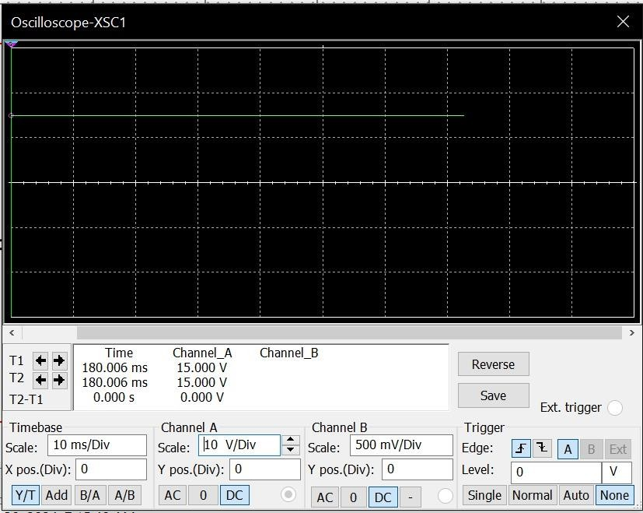

**Figure 2:Output When Buzzer is On**

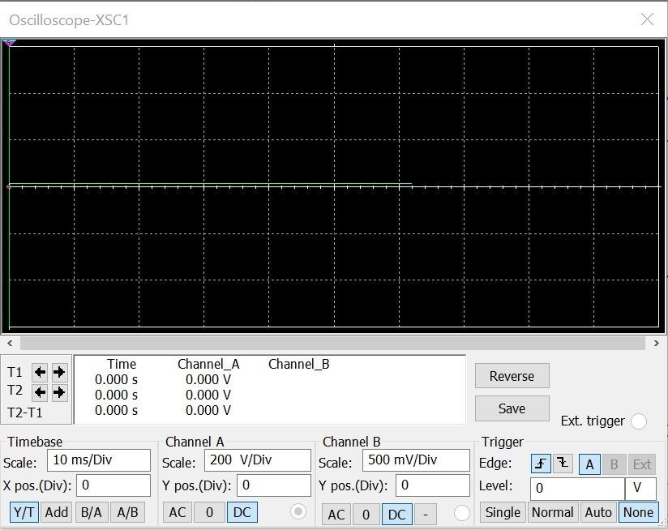

**Figure 3:Output when Buzzer is OFF**

**Results Observed:**

* The circuit **successfully detects** human presence and rings the buzzer automatically.
* The **IR sensor works effectively** to detect motion without physical contact.
* The **555 Timer IC provides a stable output pulse** to control the buzzer duration.
* The **buzzer activates and deactivates properly**, ensuring clear audible feedback.
* The oscilloscope readings confirm the expected waveforms at different test points.
* The circuit **operates reliably**, making it suitable for real-world applications like **automatic doorbell systems**.

# 8. Cost Analysis:

* **IR LED & Photodiode Pair** – 1 set (~ ₹30 / $0.40)
* **BC547 Transistor** – 1 (~ ₹10 / $0.15)
* **555 Timer IC (LM555)** – 1 (~ ₹20 / $0.25)
* **Resistors (Various Values)** – 4-5 (~ ₹10 / $0.15)
* **Capacitors (Various Values)** – 2 (~ ₹15 / $0.20)
* **Buzzer (200Hz)** – 1 (~ ₹40 / $0.50)
* **Power Supply (15V DC)** – 1 (~ ₹100 / $1.20)
* **PCB Board or Breadboard** – 1 (~ ₹80 / $1.00)
* **Wires & Connectors** – (~ ₹30 / $0.40)
* **Miscellaneous (Soldering, Housing, etc.)** – (~ ₹50 / $0.60)

**Total Estimated Cost:**

* **In INR:** ₹385 - ₹400
* **In USD:** $5.00 - $5.50

# 9.Challeges Faced :

During the simulation and testing of the **Automatic Door Bell Ringer**, I faced several challenges:

* **Sensor Sensitivity Issues:** The IR sensor wasn’t detecting objects properly in different lighting conditions. I had to adjust the positioning and resistance values to get accurate detection.
* **Noise in Circuit:** Initially, there was unwanted triggering of the buzzer due to noise in the circuit. I had to use proper grounding and add a capacitor to stabilize the signal.
* **Incorrect Timer Operation:** The 555 Timer wasn’t generating the required pulse duration for the buzzer. After debugging, I realized the capacitor value was incorrect, so I had to fine-tune it.
* **Power Supply Fluctuations:** The circuit behaved inconsistently due to voltage variations. I had to use a **regulated power supply** to ensure stable operation.
* **Component Failures:** Some of the components, especially the transistor and LED, got damaged during testing. I had to replace them and be more cautious with power ratings.
* **Simulation vs. Hardware Differences:** The circuit worked fine in simulation but had unexpected issues in real implementation. I had to re-evaluate the tolerances of the components used.

Overall, these challenges helped me understand circuit optimization and troubleshooting better. After making necessary adjustments, the circuit worked as expected!

# 10. Applications:

* **Residential Homes:** Automatically alerts homeowners when someone arrives at the door, enhancing convenience and security.
* **Offices and Corporate Buildings:** Helps in managing visitor entry by automatically ringing the bell when someone approaches.
* **Hospitals and Clinics:** Used at patient rooms or restricted areas to notify staff of visitors without requiring manual intervention.
* **Hotels and Restaurants:** Can be installed at entrances to automatically inform receptionists or waiters about arriving guests.
* **Shopping Malls and Retail Stores:** Notifies store staff when a customer enters, improving customer service and security.
* **Banks and ATMs:** Enhances security by alerting personnel when someone enters sensitive areas.
* **Schools and Colleges:** Can be used at staff rooms or principal offices to inform teachers or administrative staff about visitors.
* **Factories and Warehouses:** Alerts workers when someone enters a restricted or operational area, improving workplace safety.
* **Public Buildings and Government Offices:** Helps automate visitor notifications, reducing the need for manual door attendants.
* **Smart Homes and IoT Systems:** Can be integrated with home automation for advanced features like mobile notifications or video monitoring.

# 11. Limitations:

* **False Triggering:** The system may ring due to unwanted motion, such as passing pets, vehicles, or environmental changes (wind, light reflections).
* **Limited Detection Range:** The sensor has a specific range, beyond which it may not detect motion, leading to missed alerts.
* **Power Dependency:** Requires a constant power supply; a power outage may render the system non-functional unless backed by a battery.
* **Weather Sensitivity:** Outdoor installations may be affected by rain, dust, or extreme temperatures, reducing sensor efficiency.
* **Maintenance Required:** Components like sensors and circuits may degrade over time, requiring periodic maintenance or replacements.
* **Interference Issues:** Other electronic devices or wireless signals may interfere with the sensor’s accuracy.
* **Cost Factor:** Advanced versions with high-quality sensors and smart features can be expensive compared to traditional doorbells.
* **Privacy Concerns:** Some smart models with cameras may raise privacy concerns among visitors.
* **Installation Complexity:** Setting up the circuit, adjusting the sensor sensitivity, and integrating with existing systems may require technical expertise.
* **Limited Customization:** Basic models may not support additional features like volume control, multiple sensors, or smart connectivity.

# 12. Conclusion:

The **Automatic Door Bell Ringer** is an innovative and efficient system that enhances convenience and security by automatically ringing the doorbell when motion is detected. This experiment successfully demonstrated the working of a motion or light-based sensor integrated with a buzzer circuit to automate visitor alerts. The circuit design was tested and verified for functionality, ensuring reliable operation.

Through this implementation, we observed benefits such as hands-free operation, energy efficiency, and ease of use. However, challenges like false triggering, environmental interference, and maintenance requirements were also noted. Despite these limitations, the system proves to be a practical solution for homes, offices, and commercial spaces, reducing the need for manual doorbell operation.

# 13.References:

* <https://www.circuits-diy.com/ding-dong-doorbell-circuit-using-555-timer/>
* <https://circuitdigest.com/electronic-circuits/doorbell-circuit>
* <https://www.electronicsforu.com/electronics-projects/hardware-diy/ding-dong-door-bell>
* <https://www.eeweb.com/door-ringer-circuit-with-melodic-tone/>
* <https://roboelectrixx.com/build-touch-door-bell-alarm-circuit-using-ttp226-touch-sensor-module-and-musical-ic/>
* <https://www.electronicshub.org/ding-dong-sound-generator-circuit/>
* https://www.electronicsforu.com/electronics-projects/hardware-diy/touchless-doorbell-that-rings-only-when-hand-sanitised